Daniele Ricciardelli

ECE 4310

Gabriel Kuri

May 9, 2024

**Project 3**

**Part 1:**

**Part 2:**

*Cat /proc/cpuinfo*

There is 4 CPU cores assigned to my VM, where the model is AMD Ryzen 5 5600 6-core processor, manufactured by AuthenticAMD.

*free -m*

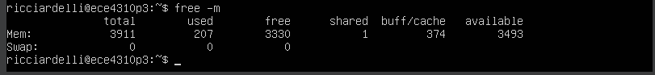

The total memory assigned to my VM is 3911MB, where 3330 is not being used, 1MB is shared, 374MB is used as buffer/cache, 207MB are currently used, and 3493MB are available and ready to be allocated. The sum of all these MB gives us the total memory, 3911MB.

*uname -a*



The linux kernel version used on my VM is 5.15.0-105-genric. It is compiled for 64-bit x86 processors. This can be easily identified by the x86_64 that is listed in the shell.

*Sudo fdisk -l /dev/sda*

The total amount of disk space allocated to my VM can be found by the total disk size

sda1_size + sda2_size + sda3_size = 1M + 1.8G + 8.2G ≈ 10G.

Thus, there’s about 10GB of disk space allocated to my VM.

*Lspci | grep Ether*



The network card installed on my VM is Intel Corporation 82540 Gigabit Ethernet Controller

**Part 3:**

**1. How many CPUs will Virtualbox let you assign to your VM? Can you assign more CPUs than are physically present in your computer?**

Virtualbox will only let me assign my maximum amount of physical CPU cores to my VM which is 12 cores. However, I can still assign more CPU cores to other VMs which can go over the amount of cores that are physically present in my PC.

**2. How much memory will Virtualbox let you assign to your VM? Will it let you assign all of your physical memory to your VM?**

Similar as with the CPU cores, VB allows me to assign a maximum of ~32GB (32768MB) of RAM which happens to be the physical memory my local PC has. However, as stated before, I can assign more memory to other VMs which can easily go over the total amount of my physical RAM on my device.

**3. Where is the virtual disk stored on the host OS? Provide a screenshot of the directory where the virtual disk is stored showing the files and their size on disk.**

The path where my VM is stored:

C:\Users\Danie\VirtualBox VMs\ECE4310P3

**4. Plug in a USB flash drive to your laptop or deskop and pass it through to your VM. Show a screenshot of the USB flash drive passed through to your VM. After it’s passed through you should be able to type lsusb at a shell to show all USB devices connected to the VM.**

